Part 2: MapReduce and Visualization of Airline Delays Using PySpark
1. Introduction
Airline delays are a common challenge in the aviation industry and can have a significant impact on passengers, airlines, airports, and the economy. Delays can be caused by several factors, including weather conditions, airline operational issues, air traffic congestion, and aircraft scheduling problems. As airlines generate large amounts of operational data every day, big data technologies provide an effective way to analyse flight performance and identify patterns that may not be visible using traditional analysis methods.
This project uses the Bureau of Transportation Statistics (BTS) On-Time Performance dataset and applies distributed data processing techniques using PySpark. The analysis focuses on identifying delay patterns during 2024, determining which airlines experienced the highest delays, and investigating the main causes of flight delays. PySpark was selected because it provides a practical way to perform large-scale distributed processing while demonstrating MapReduce concepts such as mapping, grouping, shuffling, and reduction.
2. Processing Objective and Analytical Question
2.1 Processing Objective
The aim of this analysis was to examine flight delays in the United States during 2024 using PySpark and distributed processing techniques. The project focused on identifying airlines with the highest delays, understanding monthly delay trends, and determining the most significant causes of delays.
2.2 Analytical Question
The main research question for this project was:
Which airlines and operational factors contributed most significantly to flight delays in the United States during 2024?
2.3 Expected Outcomes
The expected outcomes of the analysis were:
- To identify airlines with the highest average arrival delays.
- To investigate how delays varied throughout the year.
- To determine the major causes of delays.
- To demonstrate the use of PySpark for large-scale distributed processing.
- To provide insights that could assist airlines and airports in improving operational performance.
3. Dataset and Processing Environment
3.1 Dataset Description
The dataset used in this project was obtained from the Bureau of Transportation Statistics (BTS) On-Time Performance database. The dataset contains detailed information about domestic airline operations in the United States, including departure delays, arrival delays, airline identifiers, airports, flight dates, and delay causes.
The complete dataset collected for the project covered the period from January 2015 to December 2024.
3.2 Dataset Sizes
The project datasets were divided into three stages:
Dataset Stage | Size
Raw Dataset (2015-2024) | 26.50 GiB
Working Dataset (2020-2024) | 13.58 GiB
Processing Dataset (2024 Subset) | 7,079,061 flight records
After cleaning the processing dataset by removing cancelled flights and records with missing delay values, the analysis was conducted on 6,965,247 flight records.
3.3 Tools and Technologies
The following tools were used:
- Google Colab
- PySpark
- Python
- Pandas
- Matplotlib
- Google Drive
These tools allowed the dataset to be processed and analysed efficiently using distributed computing techniques.
4. MapReduce-Style Distributed Processing
4.1 Data Cleaning
Before analysis, several preprocessing steps were performed.
- Cancelled flights were removed.
- Records with missing arrival delays were removed.
- Records with missing departure delays were removed.
- Only the core analytical columns required for the study were retained.
After cleaning, the dataset contained approximately 6.97 million records.
4.2 Mapping Phase
The mapping phase involved selecting only the attributes that were relevant to the research question. These included:
- Reporting Airline
- Origin Airport
- Month
- Arrival Delay
- Carrier Delay
- Weather Delay
- NAS Delay
- Late Aircraft Delay
Example transformation:
mapped_df = airline_df.select(
"Reporting_Airline",
"Origin",
"Month",
"ArrDelay",
"CarrierDelay",
"WeatherDelay",
"NASDelay",
"LateAircraftDelay"
)

This reduced the complexity of the dataset and prepared it for aggregation.
4.3 Shuffle and Grouping Phase
The shuffle phase occurred when records were grouped according to specific keys, such as airline or airport.
For example:
groupBy("Reporting_Airline")

Spark redistributed records across partitions so that flights belonging to the same airline could be processed together. This stage represents the shuffle component of the MapReduce model.
4.4 Reduction Phase
The reduction phase calculated final summary statistics.
For example:
avg("ArrDelay")
was used to calculate average arrival delay for each airline.
Additional aggregation functions were used to calculate totals for the various delay categories.
5. Spark Execution and DAG Analysis
PySpark uses a Directed Acyclic Graph (DAG) execution model to process large datasets efficiently. Unlike traditional Hadoop MapReduce, Spark optimises execution plans before running jobs.
The execution plans generated using:
top_airlines.explain(True)

and

airport_delay.explain(True)

showed the following operations:
- Logical plan generation
- Query optimisation
- Hash partitioning
- Shuffle operations
- Aggregate functions
- Physical execution plans
The physical plan included HashAggregate and Exchange operations, confirming that Spark performed distributed processing and data shuffling across partitions.
Figure 1: Spark Execution Plan for Airport Delay Analysis
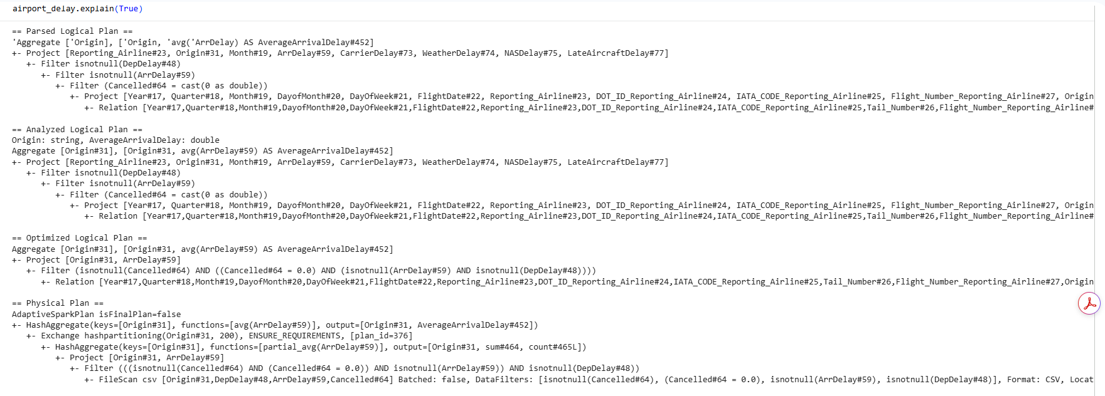
Figure 1 shows the Spark execution plan generated for the airport delay analysis. The logical plan describes the sequence of transformations applied to the data, while the optimized logical plan shows how Spark simplified the query before execution. The physical plan contains both HashAggregate and Exchange hashpartitioning operations.
The HashAggregate operation was used to calculate the average arrival delay for each airport, while the Exchange hashpartitioning operation indicates that Spark redistributed records across partitions before aggregation. This confirms that a shuffle stage occurred during processing, demonstrating the distributed execution of the analysis using Spark.

6. Results and Analysis
6.1 Airline Delay Analysis
The airline analysis showed clear differences in average arrival delays across airlines.
Airline | Average Arrival Delay (Minutes)
AA | 15.31
F9 | 15.25
B6 | 10.74
OH | 10.03
G4 | 9.71
NK | 8.42
OO | 7.36
MQ | 6.46
UA | 5.74
WN | 5.13
American Airlines (AA) recorded the highest average arrival delay at approximately 15.3 minutes, closely followed by Frontier Airlines (F9). JetBlue (B6), OH, and Allegiant Air (G4) also experienced relatively high delays.
At the opposite end of the scale, Republic Airways (YX) recorded a slightly negative average arrival delay, indicating that flights generally arrived marginally ahead of schedule.
These results suggest differences in operational efficiency, scheduling practices, fleet utilisation, and recovery from disruptions.
Figure 2: Average Arrival Delay by Airline
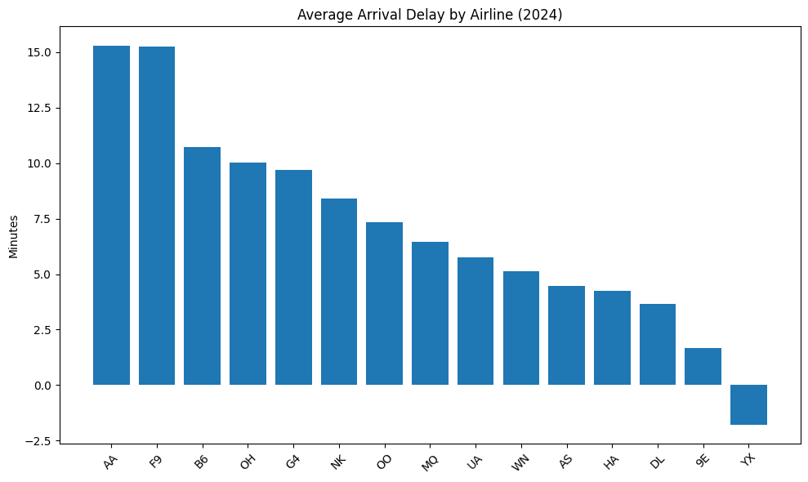
Figure 1 shows the average arrival delay for each airline included in the analysis. American Airlines (AA) recorded the highest average arrival delay at approximately 15.3 minutes, followed closely by Frontier Airlines (F9) at 15.2 minutes. JetBlue (B6), OH, and Allegiant Air (G4) also experienced relatively high delay levels. In contrast, Republic Airways (YX) recorded a slightly negative average delay, indicating that flights generally arrived a few minutes ahead of schedule. These results suggest that airline performance varies significantly, which may be influenced by factors such as operational efficiency, scheduling practices, fleet utilisation, and the ability to recover from disruptions.
6.2 Monthly Delay Trends
The monthly analysis revealed that delays were not evenly distributed throughout the year.
Month | Average Delay (Minutes)
January | 10.35
February | 0.59
March | 6.50
April | 5.36
May | 14.05
June | 11.81
July | 18.09
August | 10.59
September | 1.00
October | -1.28
November | -0.32
December | 7.12
July recorded the highest average arrival delay at approximately 18 minutes. May and June also experienced relatively high delay levels.
In contrast, October and November showed the lowest delays, with flights arriving slightly ahead of schedule on average.
The results suggest that seasonal travel demand and air traffic congestion may contribute significantly to airline delays during peak travel periods.
Figure 3: Average Airline Delay by Month
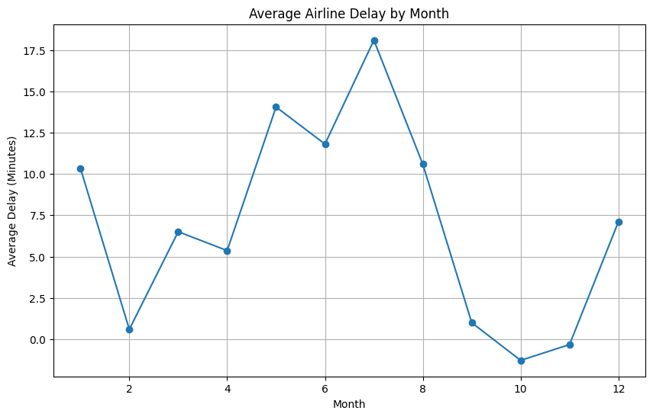
Figure 3 illustrates how average airline delays varied throughout 2024. The highest delays occurred during July, with an average arrival delay of approximately 18 minutes. Elevated delay levels were also observed during May and June. In comparison, October and November recorded the lowest average delays, with flights arriving slightly ahead of schedule on average. This pattern suggests that seasonal factors such as increased passenger demand, airport congestion, and higher flight volumes contribute to delays during peak travel periods.

6.3 Delay Cause Analysis
The delay cause analysis identified four major categories of delay.
Delay Cause | Total Delay Minutes
Late Aircraft Delay | 41.97 Million
Carrier Delay | 35.82 Million
NAS Delay | 19.62 Million
Weather Delay | 6.20 Million
Late Aircraft Delay was the largest contributor, accounting for nearly 42 million delay minutes. This occurs when an aircraft arrives late from a previous flight and affects subsequent flights scheduled for the same aircraft.
Carrier Delay was the second largest contributor at approximately 35.8 million delay minutes. These delays are generally linked to airline operational issues such as maintenance, crew scheduling, baggage handling, and other airline-controlled activities.
NAS Delay contributed approximately 19.6 million delay minutes and is typically associated with air traffic congestion and airport operations.
Weather Delay accounted for the smallest share of delay minutes in this study, suggesting that operational factors had a greater impact on overall delays during 2024.
Figure 4: Total Delay Minutes by Cause
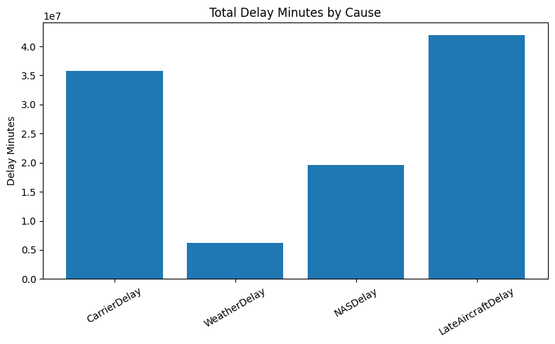
Figure 4 compares the total delay minutes associated with the major categories of delay. Late Aircraft Delay was the largest contributor, accounting for approximately 42 million delay minutes. This occurs when an aircraft arrives late from a previous flight, causing delays for subsequent scheduled flights. Carrier Delay was the second largest contributor, with approximately 35.8 million delay minutes, indicating that airline-controlled operational issues play a significant role in overall delays. NAS Delay contributed around 19.6 million delay minutes and reflects delays associated with air traffic management and airport congestion. Weather Delay accounted for the smallest share of total delay minutes, suggesting that operational factors had a greater overall impact on delays during the study period.

7. Business and Societal Value
The findings from this study provide valuable insights for airlines, airports, aviation regulators, and passengers.
For airlines, identifying carriers with consistently high delays can help management investigate operational inefficiencies and improve scheduling practices. Understanding monthly delay patterns can also assist airlines in allocating staff and resources more effectively during peak travel periods.
For airports and regulators, the results highlight the impact of congestion and operational disruptions on flight performance. Better planning and coordination may help reduce delays and improve the overall passenger experience.
The delay cause analysis showed that late aircraft delays contribute most significantly to overall delays, highlighting the importance of aircraft turnaround management and operational resilience.

8. Limitations
Although the study produced useful insights, several limitations should be acknowledged.
- The analysis focused on the 2024 subset rather than the entire historical dataset from 2015 to 2024.
- The dataset identifies categories of delays but does not provide detailed operational explanations for specific incidents.
- External factors such as staffing shortages, maintenance schedules, and operational decisions are not directly captured in the data.
- The analysis focused on average delays and did not investigate specific routes or airports in detail.

9. Conclusion
The purpose of this project was to analyse airline delays using PySpark and MapReduce-style distributed processing. More than 6.9 million flight records were processed after data cleaning, demonstrating the ability of PySpark to handle large datasets efficiently.
The analysis showed that American Airlines and Frontier Airlines experienced the highest average arrival delays during 2024. Delay patterns varied throughout the year, with July recording the highest average delays and October and November recording the lowest. The delay cause analysis revealed that late aircraft delays were the largest contributor to overall flight delays, followed by carrier-related delays.
Overall, the project demonstrated how distributed processing techniques can be used to extract meaningful insights from large datasets. The findings provide valuable information that could support decision-making within the aviation industry and contribute to improved operational performance.

